PT Activity: Layer 2 VLAN Security
Topology Diagram
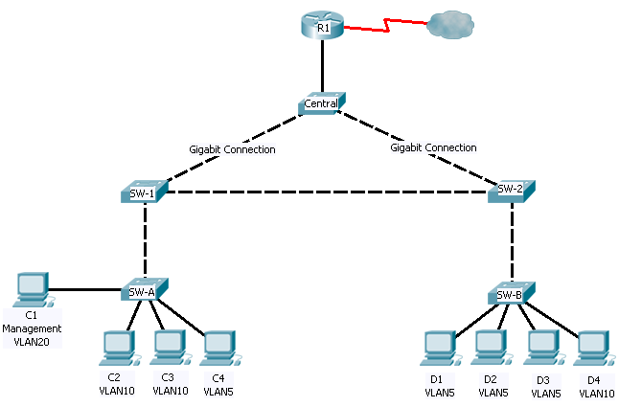
Objectives
- Connect a new redundant link between SW-1 and SW-2.
- Enable trunking and configure security on the new trunk link between SW-1 and SW-2.
- Create a new management VLAN (VLAN 20) and attach a management PC to that VLAN.
- Implement an ACL to prevent outside users from accessing the management VLAN.
Introduction
A company’s network is currently set up using two separate VLANs: VLAN 5 and VLAN 10. In addition, all trunk ports are configured with native VLAN 15. A network administrator wants to add a redundant link between switch SW-1 and SW-2. The link must have trunking enabled and all security requirements should be in place.
In addition, the network administrator wants to connect a management PC to switch SW-A. The administrator would like to allow the management PC to be able to connect to all switches and the router, but does not want any other devices to be able to connect to the management PC or the switches. The administrator would like to create a new VLAN 20 for management purposes.
All devices have been preconfigured with:
- Enable secret password: ciscoenpa55
- Console password: ciscoconpa55
- VTY line password: ciscovtypa55
- Verify Connectivity
- Verify connectivity between C2 (VLAN 10) and C3 (VLAN 10).
- Verify connectivity between C2 (VLAN 10) and D1 (VLAN 5).
If using the simple PDU GUI packet, be sure to ping twice to allow for ARP.
- Create a Redundant Link Between SW-1 and SW-2
- Connect SW-1 and SW-2.
Using a crossover cable, connect port Fa0/23 on SW-1 to port Fa0/23 on SW-2.
- Enable trunking, including all trunk security mechanisms on the link between SW-1 and SW-2.
Trunking has already been configured on all pre-existing trunk interfaces. The new link must be configured for trunking, including all trunk security mechanisms. On both SW-1 and SW-2, set the port to trunk, assign native VLAN 15 to the trunk port, and disable auto-negotiation.
SW-1(config)# interface fa0/23
SW-1(config-if)# no shutdown
SW-1(config-if)# switchport mode trunk
SW-1(config-if)# switchport trunk native vlan 15
SW-1(config-if)# switchport nonegotiate

SW-2(config)# interface fa0/23
SW-2(config-if)# no shutdown
SW-2(config-if)# switchport mode trunk
SW-2(config-if)# switchport trunk native vlan 15
SW-2(config-if)# switchport nonegotiate
- Enable VLAN 20 as a Management VLAN
The network administrator would like to be able to access all switch and routing devices using a management PC. For security, the administrator wants to ensure that all managed devices are on a separate VLAN.
- Enable a management VLAN (VLAN 20) on SW-A.
Enable VLAN 20 on SW-A and use the default name of VLAN0020.
SW-A(config)# vlan 20
SW-A(config-vlan)# exit

Create an interface VLAN 20 and assign an IP address within the 192.168.20.0/24 network.
SW-A(config)# interface vlan 20
SW-A(config-if)# ip address 192.168.20.1 255.255.255.0
- Enable the same management VLAN on all other switches.
Be sure to create the VLAN on all switches: SW-B, SW-1, SW-2 and Central.
SW-B(config)# vlan 20
SW-B(config-vlan)# exit
SW-B(config)# interface vlan 20
SW-B(config-if)# ip address 192.168.20.2 255.255.255.0

SW-1(config)# vlan 20
SW-1(config-vlan)# exit
SW-1(config)# interface vlan 20
SW-1(config-if)# ip address 192.168.20.3 255.255.255.0

SW-2(config)# vlan 20
SW-2(config-vlan)# exit
SW-2(config)# interface vlan 20
SW-2(config-if)# ip address 192.168.20.4 255.255.255.0

Central(config)# vlan 20
Central(config-vlan)# exit
Central(config)# interface vlan 20
Central(config-if)# ip address 192.168.20.5 255.255.255.0
- Configure the management PC and connect it to SW-A port Fa0/1.
Ensure that the management PC is assigned an IP address within the 192.168.20.0/24 network. Connect the management PC to SW-A port Fa0/1.
- On SW-A, ensure the management PC is part of VLAN 20.
Interface Fa0/1 must be part of VLAN 20.
SW-A(config)# interface fa0/1
SW-A(config-if)# switchport access vlan 20
SW-A(config-if)# no shutdown
- Verify connectivity of the management PC to all switches.
The management PC should be able to ping SW-A, SW-B, SW-1, SW-2 and Central.
- Enable the Management PC to Access Router R1
- Enable a new subinterface on router R1.
Create subinterface Fa0/0.3 and assign an IP address within the 192.168.20.0/24 network. Be sure to set encapsulation to dot1q 20 to account for VLAN 20.
R1(config)# interface fa0/0.3
R1(config-subif)# encapsulation dot1q 20
R1(config-subif)# ip address 192.168.20.100 255.255.255.0
- Verify connectivity between the management PC and R1.
Be sure to configure the default gateway on the management PC to allow for connectivity.
- Enable security.
While the management PC must be able to access the router, no other PC should be able to access the management VLAN.
Create an ACL(s) that denies any network from accessing the 192.168.20.0/24 network, but permits all other networks to access one another.
Example: (may vary from student configuration)
R1(config)# access-list 101 deny ip any 192.168.20.0 0.0.0.255
R1(config)# access-list 101 permit ip any any

Apply the ACL to the proper interface(s).
Example: (may vary from student configuration)
R1(config)# int fa0/0.1
R1(config-subif)# ip access-group 101 in
R1(config-subif)# int fa0/0.2
R1(config-subif)# ip access-group 101 in
There are multiple ways in which an ACL can be created to accomplish the necessary security. For this reason, grading on this portion of the activity is based on the correct connectivity requirements. The management PC must be able to connect to all switches and the router. All other PCs should not be able to connect to any devices within the management VLAN.
- Verify Security.
From the management PC, ping SW-A, SW-B, and R1. Was the ping successful?
The ping should have been successful because all devices within the 192.168.20.0 network should be able to ping one another. Devices within VLAN20 are not required to route through the router.
From D1, ping the management PC. Was the ping successful?
The ping should have failed. This is because in order for a device within a different VLAN to successfully ping a device within VLAN20, it must be routed. The router has an ACL that prevents all packets from accessing the 192.168.20.0 network.
- Check results.
Your completion percentage should be 100%. Click Check Results to see feedback and verification of which required components have been completed.
Keep in mind that if all components appear to be correct and the activity still shows incomplete, it could be due to the connectivity tests that verify the ACL operation.

